**DAILY ONLINE ACTIVITIES SUMMARY**

|  |  |  |  |  |  |  |  |  |
| --- | --- | --- | --- | --- | --- | --- | --- | --- |
| **Date:** | **07/06/2020** | | | | | **Name:** | **Hanan Saleem baji** | |
| **Sem & Sec** | **4th SEM 'A' Section** | | | | | **USN:** | **4AL18CS024** | |
| **Online Test Summary** | | | | | | | | |
| **Subject** | | **____** | | | | | | |
| **Max. Marks** | | **__** | | **Score** | | | **__** | |
| **Certification Course Summary** | | | | | | | | |
| **Course** | **1.Ethical hacking** | | | | | | | |
| **Certificate Provider** | | | **1. Great Learning Academy** | | **Duration** | | | **1. 3 hour** |
| **Coding Challenges** | | | | | | | | |
| **Problem Statement:** 1.Write a C++ program to swap two numbers using friend as bridge concept.  .  For example | | | | | | | | |
| **Status: completed** | | | | | | | | |
| **Uploaded the report in Github** | | | | | **Yes** | | | |
| **If yes Repository name** | | | | | **1.**  **https://github.com/saleemhananbaji/C-coding** | | | |
| **Uploaded the report in slack** | | | | | **Yes** | | | |

Certification Course Details: As the continuation of online course I was able to complete the initiation of ethical hacking

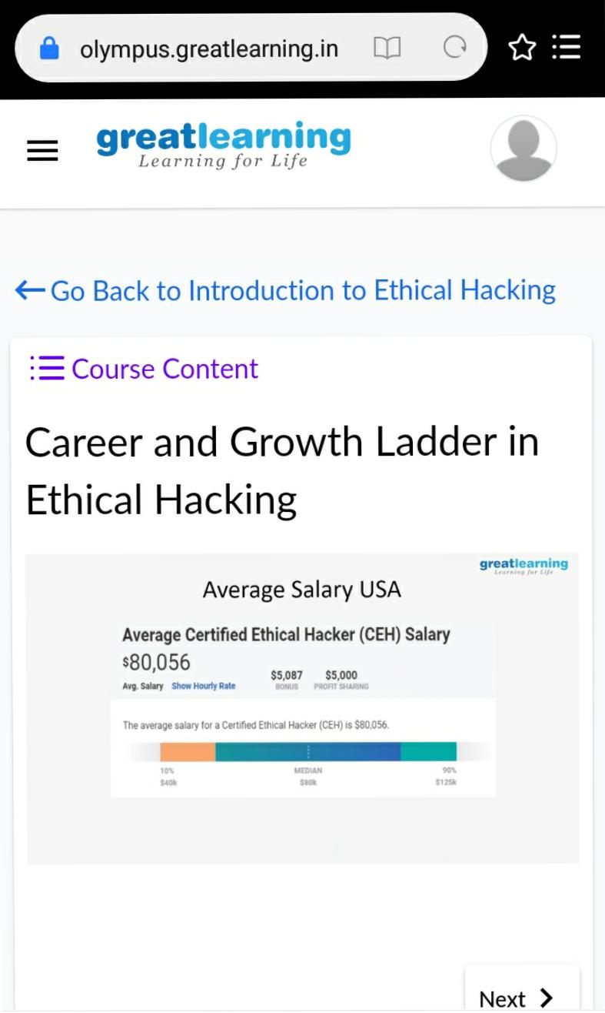Snapshot

CODING CHALLENGES DETAILS: Problem statements

**Problem Statement 1:**Write a C++ program to swap two numbers using friend as bridge concept

Solution: Uploaded it in github

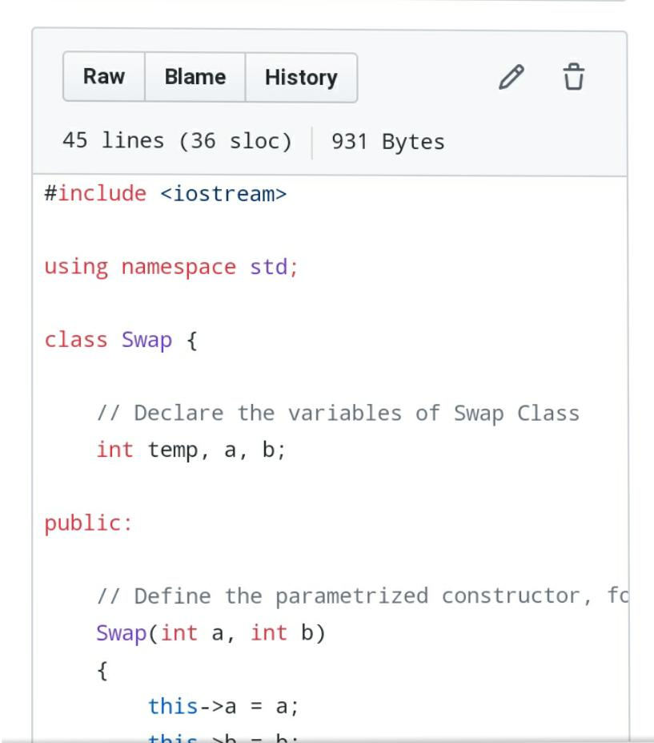**Sanpshot**